9.11: a) 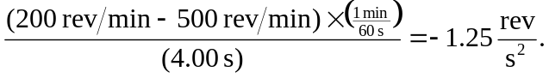
The number of revolutions is the average angular velocity, 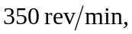times the time interval of 0.067 min, or 23.33 rev. b) The angular velocity will decrease by another in a time 